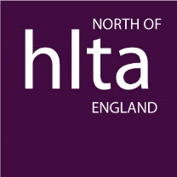

HLTA North Award for the Outstanding HLTA of the Year September 2021-September 2022

Endorsement Form (Form B)

A colleague has been proposed for the above award. Endorsement of this proposal is required for your colleague to be considered. We would therefore be grateful if you could complete the information below to endorse the information provided in the Proposal Form (Form A).

Please return the completed form r.kaye@leedsbeckett.ac.uk no later than 4 November 2022

Name of HLTA being nominated
HLTA Unique Reference Number*

* Please provide the nominee’s URN if known. HLTA status must have been gained through a partner member of HNAP (HLTA National Assessment Partnership). Each endorsement will be checked and the nominee must be able to provide a copy of their NHAP certificate as evidence of being awarded HLTA status.

Your name
Position**
Capacity in which you know the nominee

** Endorsements must be completed by a different person to the proposer. The endorser must be a senior member of staff and hold qualified teacher status.

I fully support this nomination for the Outstanding HLTA of the Year Award.
I confirm that, in my view, this colleague has maintained and developed further the standards of professional practice that were demonstrated when HLTA status was initially awarded.

Signature: __________________________

Date: _______________________

