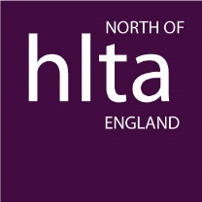

The Jenny Ellis Award for the Outstanding HLTA of the Year March 2020-July 2021

Endorsement Form (Form B)

A colleague has been proposed for the above award. Endorsement of this proposal is required for your colleague to be considered. We would therefore be grateful if you could complete the information below to endorse the information provided in the Proposal Form (Form A).

Please return the completed form r.kaye@leedsbeckett.ac.uk no later than 1st October 2021

Name of HLTA being nominated
HLTA Unique Reference Number*

* Please provide the nominee’s URN if known. HLTA status must have been gained through a partner member of HNAP (HLTA National Assessment Partnership). Each endorsement will be checked.

Your name
Position**
Capacity in which you know the nominee

** Endorsements must be completed by a different person to the proposer. The endorser must be a senior member of staff and hold qualified teacher status.

I fully support this nomination for the Outstanding HLTA of the Year Award.
I confirm that, in my view, this colleague has maintained and developed the standards of professional practice demonstrated when HLTA status was initially awarded.

Signature: __________________________

Date: _______________________

